## ASSIGNMENT FINAL REPORT

|  |  |  |  |
| --- | --- | --- | --- |
| **Qualification** | **BTEC Level 5 HND Diploma in Computing** | | |
| **Unit number and title** | **Unit 2: Networking** | | |
| **Submission date** | 09/08/2024 | **Date Received 1st submission** |  |
| **Re-submission Date** |  | **Date Received 2nd submission** |  |
| **Student Name** | Nguyễn Thế Hùng | **Student ID** | BH01689 |
| **Class** | SEO7203 | **Assessor name** | Nguyễn Thị Hồng Hạnh |
| **Plagiarism**  Plagiarism is a particular form of cheating. Plagiarism must be avoided at all costs and students who break the rules, however innocently, may be penalised. It is your responsibility to ensure that you understand correct referencing practices. As a university level student, you are expected to use appropriate references throughout and keep carefully detailed notes of all your sources of materials for material you have used in your work, including any material downloaded from the Internet. Please consult the relevant unit lecturer or your course tutor if you need any further advice.  **Student Declaration**  I certify that the assignment submission is entirely my own work and I fully understand the consequences of plagiarism. I declare that the work submitted for assessment has been carried out without assistance other than that which is acceptable according to the rules of the specification. I certify I have clearly referenced any sources and any artificial intelligence (AI) tools used in the work. I understand that making a false declaration is a form of malpractice. | | | |

|  |  |
| --- | --- |
| **Student’s signature** | Hùng |

**Grading grid**

|  |  |  |  |  |  |  |  |  |  |  |  |  |  |
| --- | --- | --- | --- | --- | --- | --- | --- | --- | --- | --- | --- | --- | --- |
| P1 | P2 | P3 | P4 | P5 | P6 | P7 | P8 | M1 | M2 | M3 | M4 | D1 | D2 |
|  |  |  |  |  |  |  |  |  |  |  |  |  |  |

|  |  |  |
| --- | --- | --- |
| * **Summative Feedback:**  **Resubmission Feedback:** | | |
| **Grade:** | **Assessor Signature:** | **Date:** |
| **Internal Verifier’s Comments:** | | |
| **Signature & Date:** | | |

**P1, P2, M1, P3, P4, M2, D1, P5, P6, M3, P7, P8, M4, D2.**

# Introduction

- You are employed as a Network Engineer by Nguyen Networking Limited, a high-tech networking solution development company, which have branches in Ho Chi Min City,

Hanoi, Da Nang and Can Tho.

The company has been contracted to implement a networking project from a local educational institute. The specification of the project is given below:

People: 200 students, 15 teachers, 12 marketing and administration staff, 5 higher managers including the head of academics and the programme manager, 3 computer network administrators. Resources: 50 student lab computers, 35 staff computers, 3 printers.

Building: 3 floors, all computers and printers are on the ground floor apart from the IT labs – one lab located on the first floor and another located on the second floor.

# Content P1.

### I. Discuss the benefits and constraints of different network types and standards.

##### What is computer networking?

* A computer network is a system of computers and other devices connected together to share resources and information.
* The goal of a computer network is to enable efficient access and sharing of data, applications, and other resources between devices on the network.
* Computer networks can be built using copper cables, fiber optic cables, or wireless connections.

##### Common Types of Networks: LAN, WAN, MAN, PAN,…(define, type, benefit, constrain

**…)**

**- LAN** (Local Area Network):



*Table 1: LAN (Local Area Network)*

+ **Definition:** LAN is a computer network limited to a certain area such as an office, a building or a school.

+ **Type:** Local area network.

+ **Benefits:** Fast transmission speed, low cost, easy to manage and maintain.

+ **Limitations:** Limited range, cannot expand too far.

**- WAN**(Wide Area Network)

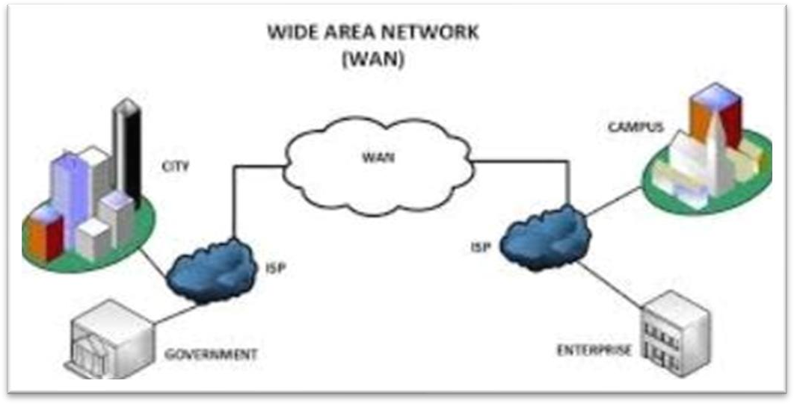

*Table 2: WAN(Wide Area Network)*

+ **Definition:** WAN is a distributed computer network over a large area, usually national or global.

+ **Type:** Local area network.

+ **Benefits:** Connecting remote locations, accessing remote resources.

+ **Limitations:** High cost, high latency.

**- MAN** (Metropolitan Area Network)

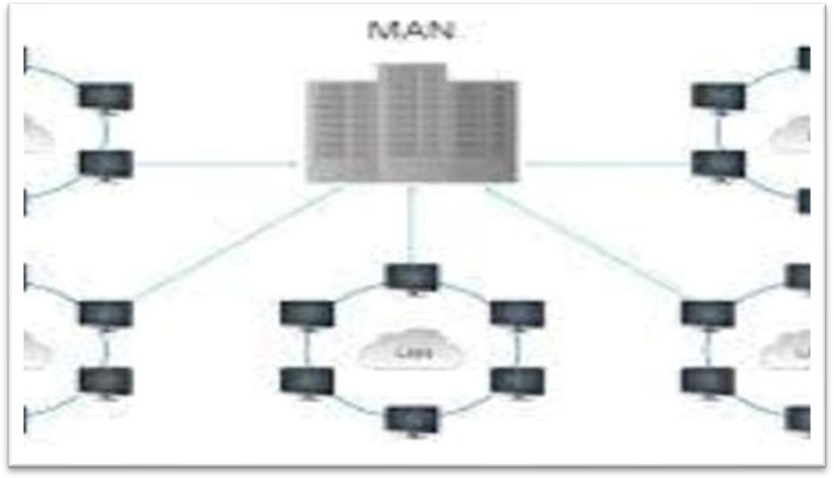

*Table 3: MAN (Metropolitan Area Network)*

**+ Definition:** MAN is a distributed computer network within an urban area or city.

+ **Type:** Local area network.

+ **Benefits:** Connecting areas within a city, providing services to large businesses.

+ **Limitations:** Cost of deployment and maintenance

**- PAN**(Personal Area Network)

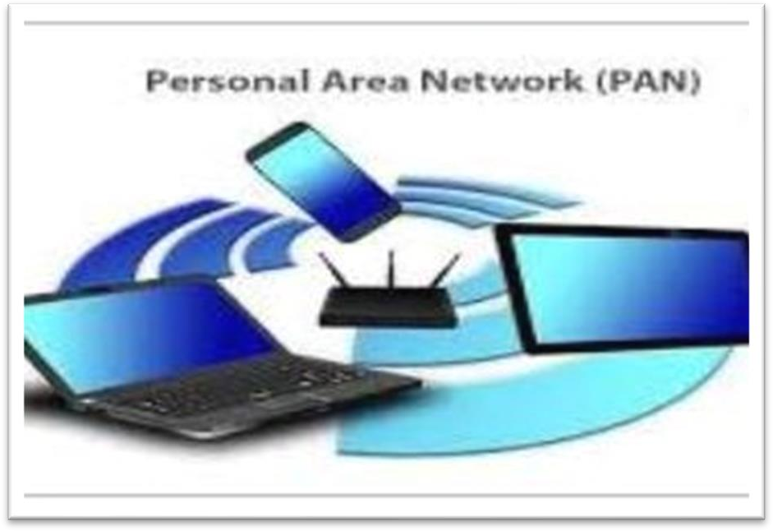

*Table 4: PAN(Personal Area Network)*

+ **Definition:** A PAN is a personal computer network, typically connecting personal devices such as cell phones, tablets, and computers.

+ **Type:** Local area network.

+ **Benefits:** Connect personal devices, share small resources.

+ **Limitations:** Short range, cannot connect to remote devices.

##### - Intranet:

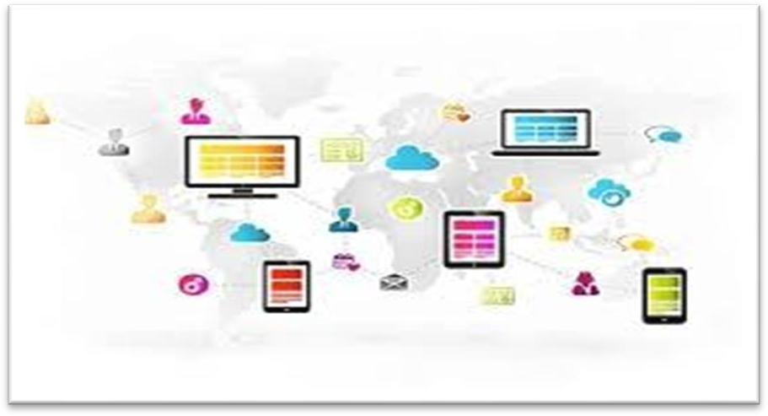

*Table 5: Intranet*

**+ Definition:** A PAN is a personal computer network, typically connecting personal devices such as cell phones, tablets, and computers.

+ **Type:** Local area network.

+ **Benefits:** Connect personal devices, share small resources.

+ **Limitations:** Short range, cannot connect to remote devices.

**- Extranet:**

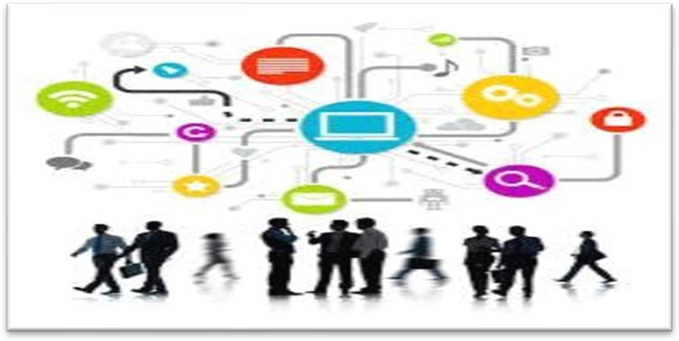

*Table 6: Extranet*

**Definition:** Extranet is an extension of an organization's intranet, allowing connection and exchange of information with partners or customers outside that organization.

**+ Benefits:** Easy communication and collaboration with external partners and customers, strengthening business relationships.

**+ Limitations:** Access control and security are needed to ensure the safety of organizational information.

##### Protocol and Standards:

* **Protocol:**

A protocol is a set of rules that define or standardize the way information is exchanged between devices, software, or components in a network computer or system. The protocol defines the rules and data formats to ensure subsequent transactions and the resulting communication of information between parties. The goal of the protocol is to ensure compatibility, uniformity and reliability in the information exchange process.

* **Standard:**

A standard is a document containing regulations, technical requirements or guidelines approved by an organization, standardization body or large community to ensure that products, processes or services meet common and interoperable requirements. Standards provide a legal and technical framework for the development, deployment and evaluation of products and services in a specific sector.

### Standards (ISO, IEEE, IETF, W3C, … - history, role …)

##### ISO (International Organization for Standardization)

**+ History**: ISO was founded in 1947 and is headquartered in Geneva, Switzerland. ISO's main mission is to develop and produce international standards that ensure quality and efficiency in various industrial sectors.

**+ Role**: ISO plays an important role in developing computer network standards,including standards related to network management, information security and network service management.

##### IEEE (International Organization for Standardization)



*Table 8: IEEE (International Organization for Standardization)*

**+ History**: IEEE was founded in 1963 and is headquartered in New York, USA. This

organization focuses on developing standards in the field of electrical and electronics engineering.

**+ Role**: IEEE plays an important role in developing computer networking standards, including Ethernet standards, Wi-Fi, and other standards related to networking and communications protocols.

##### IETF (Internet Engineering Task Force)

*Table 9: IETF (Internet Engineering Task Force)*

**+ History**: The IETF was founded in 1986 and is an informal organization, operating under the Internet Society. The IETF focuses on developing and standardizing Internet- related protocols and technologies.

**+ Role**: The IETF is responsible for developing and maintaining Internet protocol standards such as TCP/IP, HTTP, SMTP, and others.

- **W3C (World Wide Web Consortium)**

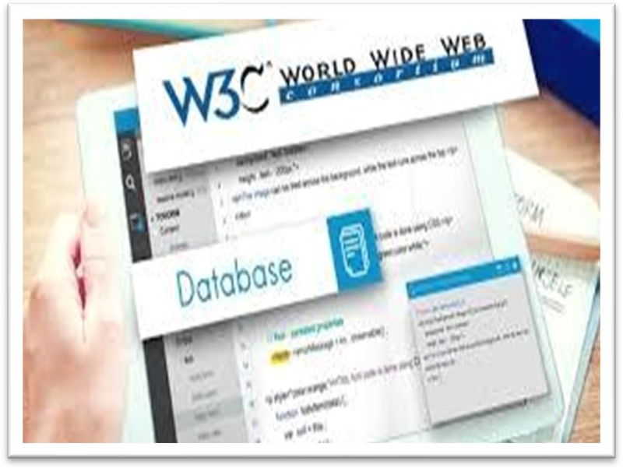

*Table 10: W3C (World Wide Web Consortium)*

**History**: W3C was founded in 1994 and is headquartered in Cambridge, Massachusetts, United States. This organization focuses on developing standards and guidelines related to the World Wide Web.

**+ Role**: W3C is responsible for developing web standards such as HTML, CSS, and other standards related to web semantics, accessibility, and mobile web.

### History , Role:

* + - ISO (International Organization for Standardization)

+ **ISO 9001:** Quality management standard, applicable to organizations wishing to improve the effectiveness of their quality management system and enhance customer satisfaction.

+ **ISO 14001:** Environmental standard, supports organizations in establishing and maintaining effective environmental management systems.

+ **ISO 27001:** Information security standard, defines the requirements for establishing, implementing, maintaining and improving an information security management system within an organization.

* + - IEEE (Institute of Electrical and Electronics Engineers)

+ **IEEE 802.11:** WLAN (Wireless Local Area Network) standard, mainly applied to Wi-Fi networks.

+ **IEEE 802.3:** Ethernet standard, defines the operating methods of Ethernet networks.

+ **IEEE 754:** Floating-point number processing standard, defining the format and rules for performing floating-point number operations on computers.

* + - IETF (Internet Engineering Task Force)

+ **RFC 791:** IPv4 standard (Internet Protocol version 4), defines the structure and operation of IP addresses in the Internet.

+ **RFC 2616:** HTTP (Hypertext Transfer Protocol) standard, describes how web servers and web browsers communicate with each other.

+ **RFC 3261:** SIP (Session Initiation Protocol) standard, used for establishing, maintaining and destroying communication sessions on IP networks.

* + - W3C (World Wide Web Consortium)

+ **HTML5:** Hypertext Markup Language, used to create and define the structure of web pages.

+ **CSS:** Cascading Style Sheets, used to format and improve the user interface of websites and web applications.

+ **XML:** Extensible Markup Language, used to store and transmit data in structured text form.

I. The impact of network topology, speed of communication and bandwidth requirements.

1. Network topology :

**-** Network architecture is the organizational layout and design of a network system, including the basic components and how they work together to communicate data and resources. The network architecture defines the rules and protocols so that devices and systems can communicate with each other effectively and meet user requirements.

### Define network topology



*Table 11: Define network topology*

* + - **Star Topology**: In this network, devices connect to a control center, such as a switch or hub. All devices communicate through this hub.
    - **Bus Topology (Bus Network)**: In this network, devices are connected in a form of "bus wire" running along the network. Devices communicate directly with this bus.
    - **Ring Topology**: In this network, devices are connected in a continuous ring. Data is transmitted from one device to another in the direction of the ring.
    - **Mesh Topology**: In this network, each device is connected to every other device in the network. This creates a powerful and flexible network but may require more connections and management.
    - **Hybrid Topology**: A combination of two or more different topologies. For example, a network can combine a star network and a ring network.

**+ Division by function :** Network Physical Topology and Network Logical Topology

1. Divided by function

### Network Physical Topology :

*Table 12: Network Physical Topology*

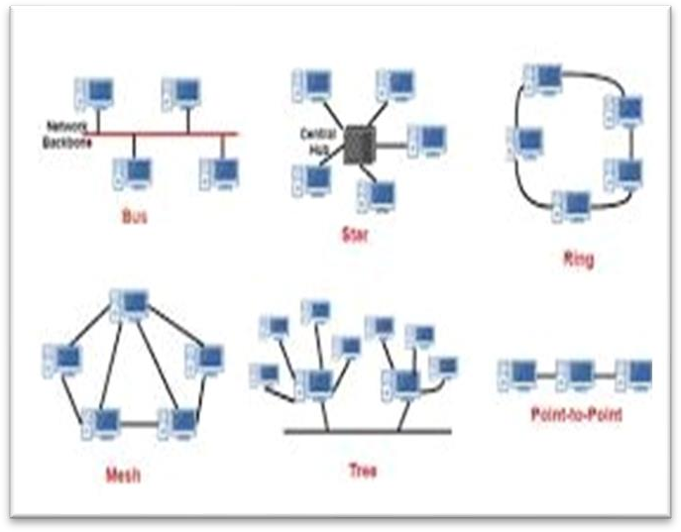

* **Define**: Network Physical Topology describes how network devices are connected to each other through physical links, including cables, fiber optics, or wireless connections.
* **Function**: Describes how physical devices are placed and connected to each other in the network. It defines the physical location of devices, the data transmission paths between them, and the means of connection.

##### Network Logical Topology:

- Network Logical Topology refers to the conceptual layout or arrangement of devices, nodes, and connections in a computer network. Unlike Physical Topology, which deals with the physical arrangement of devices and cables, Logical Topology focuses on how data is transmitted between nodes regardless of their physical placement.

* 1. **Divided by connection form:**

### - Wide Area Network (WAN):

*Table 13: Wide Area Network (WAN)*

+ Point-to-Point :

* + - Each location is connected to all other locations.
    - Provides high flexibility and reliability in data transmission, but requires multiple connections.

+ Star:

* + - All locations connect to a control center or network hub.
    - Often used in WAN systems to manage and control data transmission.

+ Mesh:

* + - Each location is connected to all other locations.
    - Provides high flexibility and reliability in data transmission, but requires multiple connections.
* Local Area Network (LAN):

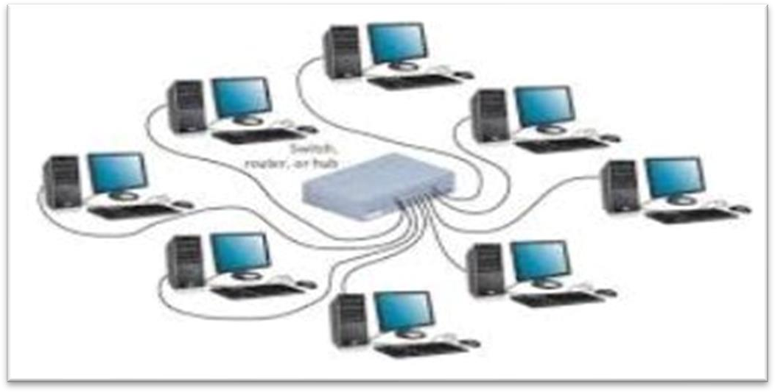

*Table 14: Local Area Network (LAN)*

+ Star :

* + A control hub (such as a switch) connects the devices together.
  + Easy to manage and expand, often used in office environments.

+ Bus :

* + The devices are connected in the form of wires (bus), information is transmitted back and forth on the wire.
  + Simple and low cost, but can be error prone.

+ Ring :

* + Each device connects to two other devices, forming a continuous ring.
  + Data is transmitted in the direction of the ring, providing high performance but not flexibility.

+ tree :

* + A hierarchical network with one or more control centers connecting the branches.
  + Common in large organizations with many departments or floors.

+ Hybrid :

* + Combination of two or more different topologies.
  + Provides flexibility and hybrid performance of different connection forms.

##### Communication

* 1. **Define commutations in terms of networking**

**+ Data Exchange:** Communications involve the transmission and reception of data packets between devices. These data packets can contain various types of information, including text, images, audio, video, or any other form of digital data.

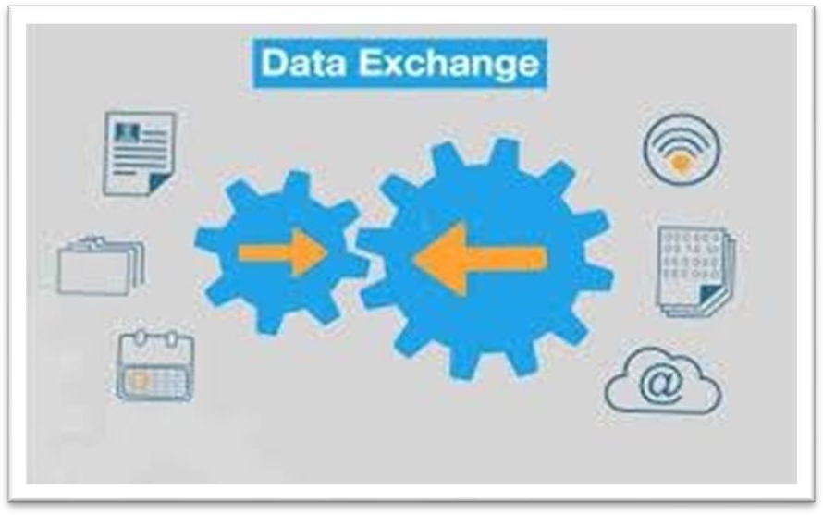

*Table 15: Data Exchange*

**+ Protocols and Standards:** Communications in networking rely on specific protocols and

standards to ensure that data exchange is structured, efficient, and secure. Protocols such as TCP/IP (Transmission Control Protocol/Internet Protocol) define the rules and procedures for communication between devices.

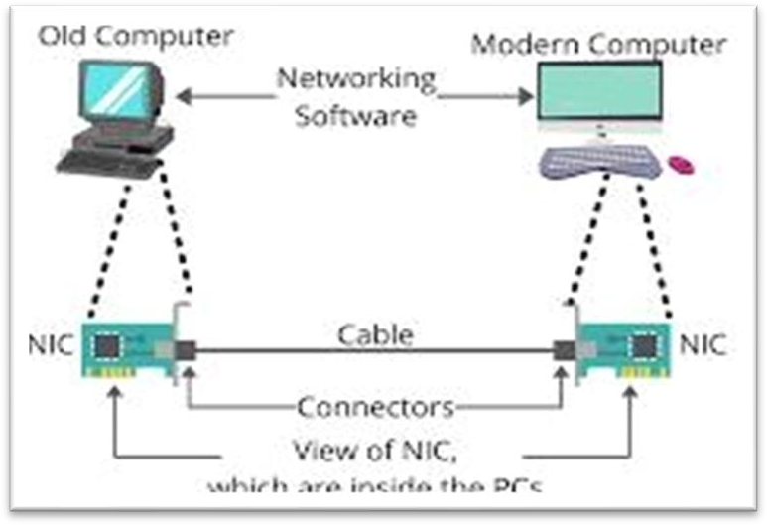

*Table 16: Protocols and Standards*

**+ Modes of Communication:** Communications in networking can occur through different modes, including:

* Unicast: Data is sent from one sender to one receiver.
* Multicast: Data is sent from one sender to multiple receivers.
* Broadcast: Data is sent from one sender to all devices within the network.
* Anycast: Data is sent from one sender to the nearest of several receivers.

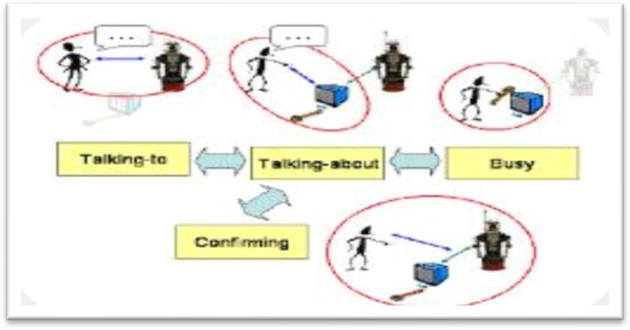

*Table 17: Modes of Communication*

**+ Routing and Switching**: Communications involve routing and switching mechanisms to ensure that data packets are directed to their intended destinations efficiently. Routers and switches play crucial roles in directing traffic within a network based on destination addresses.

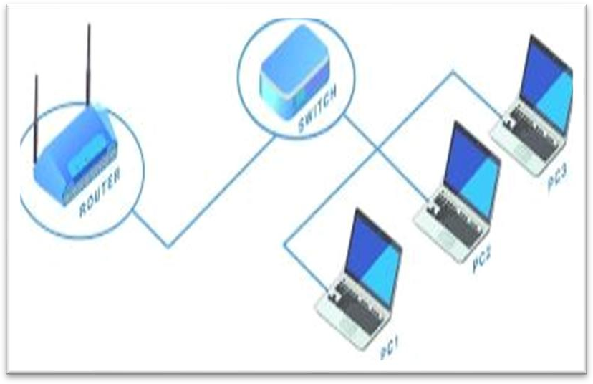

*Table 18: Routing and Switching*

**+ End-to-End Connectivity**: Communications aim to establish end-to-end connectivity between devices regardless of their physical locations within the network. This connectivity ensures that data can be exchanged seamlessly between devices across the

network.

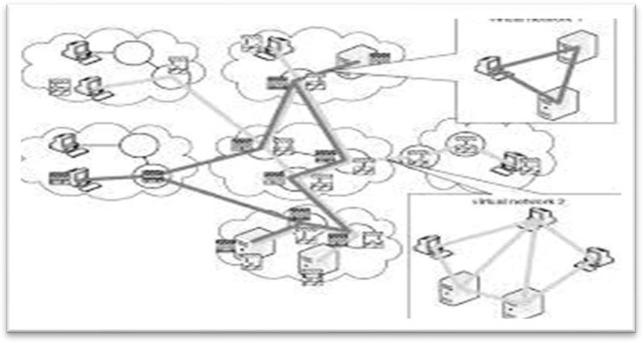

*Table 19: End-to-End Connectivity*

* 1. Rules of communication:



*Table 20: Rules of communication*

**+ Protocol Compliance**: Devices communicating over a network must adhere to the same communication protocols and standards. Protocols like TCP/IP, HTTP, FTP, and SMTP define rules for data exchange, addressing, error handling, and more.

**+ Addressing**: Each device in a network must have a unique identifier, such as an IP address, MAC address, or hostname, to facilitate routing and delivery of data packets to the intended

recipient.

**+ Packetization**: Data is broken down into smaller units called packets before transmission. Each packet contains a portion of the original data, along with necessary headers for routing and error detection.

**+ Error Detection and Correction**: Mechanisms like checksums, cyclic redundancy checks (CRC), and acknowledgment mechanisms are used to detect and correct errors that may occur during data transmission.

**+ Flow Control**: Flow control mechanisms regulate the rate of data transmission between sender and receiver to prevent congestion and ensure smooth data flow across the network.

**+ Reliability**: Communication protocols often incorporate features like acknowledgments, retransmissions, and sequence numbers to ensure reliable delivery of data, even in the presence of network errors or congestion.

**+ Security**: Encryption, authentication, and access control mechanisms are employed to safeguard data confidentiality, integrity, and availability, protecting it from unauthorized access, interception, or modification.

**Quality of Service (QoS)**: QoS mechanisms prioritize certain types of traffic (e.g., voice or video) over others to ensure consistent performance and meet specific service level agreements (SLAs) for latency, jitter, and bandwidth requirements.

**+ Compatibility**: Devices and systems from different vendors must be able to communicate and interoperate seamlessly. Compliance with industry standards and protocols ensures compatibility and interoperability across heterogeneous network environments.

**+ Scalability and Flexibility**: Communication systems should be designed to accommodate growth and changes in network size, topology, and traffic patterns without requiring significant modifications or disruptions.

##### Speed of communication and bandwidth requirements Bandwidth, throughput, goodput,

**…**

### Define network bandwidth:

* **Use Measurement Tools**: There are many software tools and online services that can be used to measure network bandwidth speed. This tool often performs data transfer tests over networks and measures transmission speeds.
* **Using Terminal Commands**: In some operating systems such as Windows or Unix/Linux, you can use commands such as ping, tracert, or iperf to measure network bandwidth.
* **Network Devices**: Some network devices such as routers or switches can also provide network bandwidth information on their interfaces.
* **Check System Resources**: In some cases, you can use system management or resource monitoring tools to view network bandwidth used on network devices or personal computers.

### How does bandwidth work

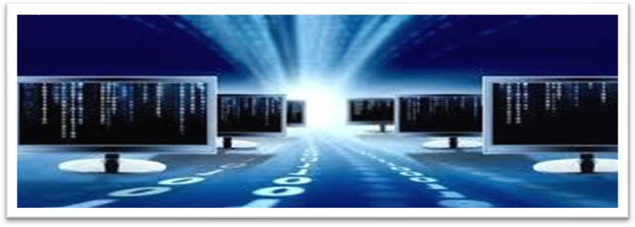

*Table 22: How does bandwidth work*

* **Sending Data**: Every data transfer process on the network starts with a device sending data. Data can be any type of information, from text messages, images, audio to video.
* **Data Segmentation**: Data sent from the source device is often divided into smaller

segments called packets or frames. This process helps manage data effectively and ensures transmission integrity and performance.

* **Address Assignment and Encapsulation**: Each packet is assigned a source and destination address as well as other control information such as a packet sequence number. The packet is then packaged into frames or data packets ready for transmission.
* **Data Transmission**: Data packets are transmitted from the source device to the destination device over network lines. This process often involves using transmission media such as copper cables, fiber optic cables, or wireless connections.
* **Data Reception and Processing**: At the destination device, packets are received and then processed to reconstruct the original data. This process may include data integrity checking, packet reordering, and original data reconstruction.
* **Response and Acknowledgment**: In some cases, the destination device may send acknowledgments back to the source device to indicate that the data was successfully received. These assertions can help regulate data transmission and ensure its integrity.

**-** Bandwidth needs by audience size:



*Table 23: Bandwidth needs by audience size*

* 1. **Small Audience (1-10 Users):**

#### For small audiences, such as a small office or home network, a basic internet connection with speeds ranging from 10 Mbps to 100 Mbps may suffice.

* This level of bandwidth is typically suitable for basic web browsing, email, and light streaming or downloading activities.

+ Medium Audience (10-100 Users):

#### A medium-sized audience, such as a small business or classroom, may require higher bandwidth ranging from 100 Mbps to 1 Gbps.

* + This level of bandwidth can support multiple users engaging in activities such as video conferencing, online collaboration, file sharing, and moderate streaming or downloading.

+ Large Audience (100-1,000 Users):

* + For larger audiences, such as a large organization, educational institution, or event venue, bandwidth requirements can range from 1 Gbps to 10 Gbps or more.
  + Higher bandwidth is necessary to accommodate simultaneous connections from multiple users engaging in bandwidth-intensive activities, such as live streaming, online gaming, video broadcasting, and large file transfers.

+ Very Large Audience (1,000+ Users):

* + Very large audiences, such as those attending a major event or accessing popular online services, may require extensive bandwidth capacity ranging from 10 Gbps to 100 Gbps or beyond.
  + This level of bandwidth is necessary to handle the massive influx of simultaneous connections and data traffic generated by a large number of users accessing content or services concurrently.

##### Assess common networking principles and how protocols enable the effectiveness of networked systems.

**Common Networking Principles:**

* **Scalability:** Networks should be designed to accommodate growth in size and traffic without significant performance degradation. Scalability is achieved through proper network design, efficient protocols, and scalable hardware.
* **Reliability:** Networks must ensure that data is reliably transmitted from source to destination without loss or corruption. This principle is supported by error detection and correction mechanisms in protocols.
* **Performance:** Networks should provide adequate speed and responsiveness to meet user demands. This includes optimizing data transfer rates, minimizing latency, and managing bandwidth effectively.
* **Security:** Ensuring the confidentiality, integrity, and availability of data is critical. Security principles involve authentication, encryption, access control, and threat detection mechanisms.
* **Manageability:** Networks should be easy to monitor, configure, and manage. This principle is supported by network management protocols that enable centralized control, monitoring, and troubleshooting.
* **Interoperability**: Different types of networks and devices should be able to communicate effectively. Interoperability is achieved through adherence to standardized protocols and formats.

### Model OSI, TCP/IP (definitions, how they work, comparison ..)

##### Definition:

**+** The OSI model is a theoretical framework developed by the ISO Organization (International Organization for Standardization), to describe and standardize the functions of computer systems. This model divides the network into 7 layers, each layer must receive a role tool in the process of transmitting data from user to user.

##### How it works :

+ The OSI model divides the computer network into 7 layers, each layer takes on specific

functions and links with other layers to ensure efficient and reliable data communication from source to destination.

* + **OSI Model:** Divides the computer network into 7 layers, each layer takes on specific functions and links with other layers to ensure network data communication.
  + **TCP/IP Model:** Divides computer networks into 4 layers, focuses on practical implementation and is widely used in networks, especially the Internet, with protocols such as TCP and IP as the center.

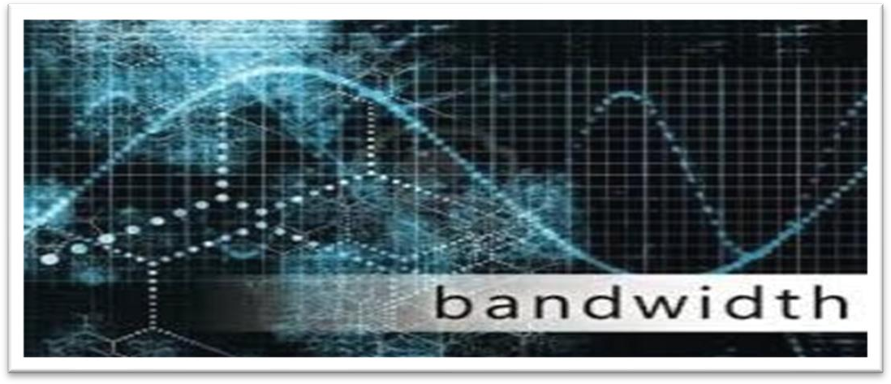

*24: How it works*

**- Model OSI (Open Systems Interconnection):**

*Table 25: Model OSI (Open Systems Interconnection)*

**+ Definition:** The OSI model is a structure that describes the framework and functions of a network layer system, developed by ISO (International Organization for Standardization). It divides the network structure into 7 layers, from the physical layer to the application layer.

**+ How it works:** Each layer in the OSI model has a task engine and operates independently of other layers. Data is transmitted from the upper layer to the lower layer through the process of packaging (encapsulation) and from the lower layer up through the process of unpacking (depackaging).

+ Work:

* + **Physical layer**: Defines the physical and electronic standards of transmission media.
  + **Data Link Layer**: Manages access to transmission media, controls errors, and identifies physical addresses.
  + **Network layer**: Manages logical addresses, routing and switching of data between different networks.
  + **Transport layer**: Manages data transmission between network devices, ensuring reliability and error control.
  + **Session layer**: Manages the establishment, maintenance, and termination of communication sessions between applications.
  + **Presentation layer**: Ensures data integrity and converts data formats if necessary.
  + **Application layer**: Provides network services to applications, such as file transfers, web page access, and email sending.

##### Common protocols (based on model osi – TCP/ UDP on layer 4, Ipv4 on layer 3)

* **Layer 4**: Transport Layer

+ TCP (Transmission Control Protocol):

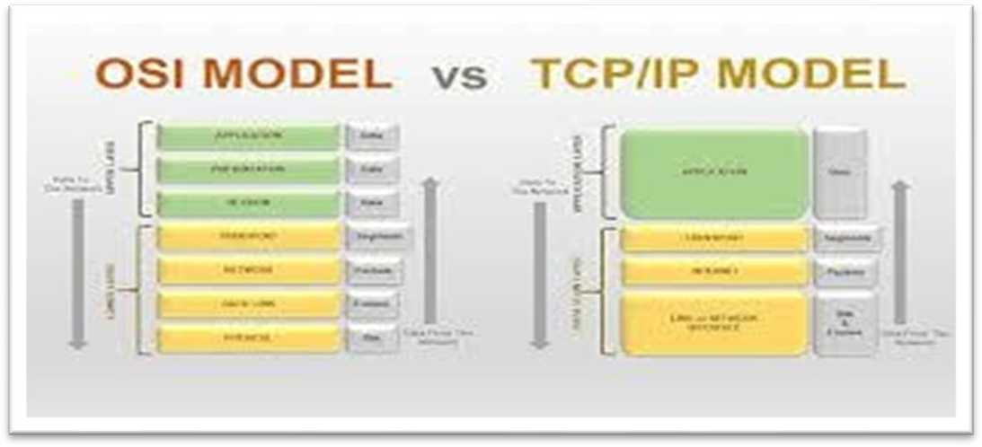

*Table 27: TCP (Transmission Control Protocol)*

* + **Definition**: TCP is a connection-oriented protocol that provides reliable, ordered, and error-checked delivery of data between applications.
  + **Common Applications**: Web browsing, email (SMTP), file transfer (FTP), remote terminal access (SSH), and more.

##### + UDP (User Datagram Protocol):

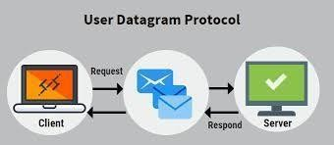

*Table 28: UDP (User Datagram Protocol)*

* + **Definition**: UDP is a connectionless protocol that provides low-overhead, unreliable, and unordered delivery of data between applications.
  + **Common Applications**: Real-time multimedia streaming, online gaming, VoIP (Voice over IP), DNS (Domain Name System), and more.
* **Layer 3**: Network Layer

##### + IPv4 (Internet Protocol version 4):

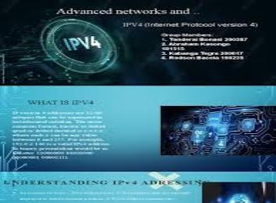

*Table 29: IPv4 (Internet Protocol version 4)*

* + **Definition**: IPv4 is the fourth version of the Internet Protocol, responsible for addressing and routing packets of data so that they can travel across networks and arrive at the correct destination.
  + **Common Features**: 32-bit IP addresses, hierarchical addressing scheme, fragmentation and reassembly of packets, and routing tables.
  + **Common Applications**: All internet communication relies on IPv4 for addressing and routing, including web browsing, email, file transfer, and more.

##### - Comparison:

* + **TCP vs. UDP**: TCP provides reliable, ordered, and error-checked delivery of data, making it suitable for applications that require data integrity and sequencing, such as web browsing and file transfer. UDP, on the other hand, sacrifices reliability for lower latency, making it suitable for real-time applications like video streaming and online gaming.
  + **TCP/UDP vs. IPv4**: TCP and UDP operate at layer 4 and manage communication between applications, while IPv4 operates at layer 3 and handles addressing and routing of packets across networks. Together, these protocols enable end-to-end communication over the internet and other networks.

##### How protocols enable the effectiveness of networked systems.

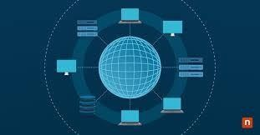

*Table 30: how protocols enable the effectiveness of networked systems*

* + **Standardization**: Protocols establish standardized rules and formats for communication between devices and systems. This standardization ensures interoperability, allowing devices and systems from different vendors to communicate seamlessly.
  + **Efficient Communication**: Protocols define efficient methods for exchanging data between devices and systems. By specifying how data is formatted, transmitted, and interpreted, protocols enable efficient communication, minimizing overhead and maximizing throughput.
  + **Reliability**: Many protocols, such as TCP (Transmission Control Protocol), include mechanisms for ensuring reliable delivery of data. These mechanisms include error detection, error correction, flow control, and congestion avoidance, which enhance the reliability of communication over unreliable networks.
  + **Scalability**: Protocols are designed to scale to accommodate networks of various sizes, from small local networks to large global networks like the internet. Scalability features.

built into protocols ensure that networked systems can grow and adapt to changing requirements without sacrificing performance or reliability.

* + **Security**: Protocols often include security features to protect data and ensure the privacy and integrity of communication. These security features may include encryption, authentication, access control, and data integrity checks, which help mitigate security threats and vulnerabilities in networked systems.
  + **Flexibility**: Protocols are designed to be flexible and extensible, allowing for the development of new services and applications without requiring major changes to the underlying network infrastructure. This flexibility enables innovation and the rapid deployment of new technologies in networked systems.

### Discuss the operating principles of networking devices and server types.

##### Network devices:

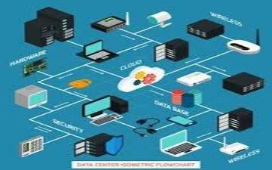

*Table 31: 1.Network devices*

##### Definition of Network Devices:

* + - * Network devices are physical or virtual components that facilitate communication and data exchange within a computer network. These devices are essential for connecting computers, servers, peripherals, and other networked devices to each other and to the internet.

Network devices can include hardware devices such as routers, switches, hubs, access points, network interface cards (NICs), modems, and gateways, as well as software- based

devices like virtual routers, virtual switches, and network appliances.

##### Functions of Network Devices:



* + - * **Router:**

*Table 32: Functions of Network Devices*

**+ Function**: Routers are network devices that forward data packets between computer networks. They determine the best path for data transmission based on routing tables and network protocols.

##### - Key Functions:

+ Routing data between networks

+ Network address translation (NAT)

+ Packet filtering and firewall capabilities

+ Quality of Service (QoS) management

+ Virtual Private Network (VPN) support

##### Switch:

**+ Function**: Switches are network devices that connect multiple devices within a local area network (LAN). They forward data packets to the appropriate destination based on MAC addresses.

##### Key Functions:

+ Forwarding data within a LAN

+ MAC address learning and table maintenance

+ VLAN (Virtual LAN) support

+ Port mirroring for network monitoring

+ Power over Ethernet (PoE) for powering devices

##### Hub:

**+ Function:** Hubs are basic network devices that connect multiple devices within a LAN. They operate at the physical layer of the OSI model and simply broadcast data to all connected devices.

##### Key Functions:

+ Broadcasting data to all connected devices

+ Simple and inexpensive network connectivity

+ Limited collision detection (in half-duplex mode)

+ Deprecated in favor of switches for better performance

##### Access Point (AP):

**+ Function:** Access points are devices that enable wireless devices to connect to a wired network. They serve as the central connection point for wireless clients, providing access to the network infrastructure.

##### Key Functions:

+ Providing wireless connectivity to devices

+ SSID broadcasting and management

+ Security features such as encryption and authentication

+ Signal coverage optimization and roaming support

##### Network Interface Card (NIC):

**+ Function:** NICs are hardware components that enable devices to connect to a network. They provide the physical interface between a device and the network medium, such as Ethernet cables or wireless signals.

##### Key Functions:

+ Transmitting and receiving data packets

+ MAC address assignment and identification

+ Network speed and duplex mode negotiation

+ Error detection and reporting

##### Modem:

**+ Function:** Modems are devices that modulate and demodulate digital data to enable communication over analog transmission mediums, such as telephone lines or cable systems. They convert digital signals from computers into analog signals for transmission and vice versa.

##### - Key Functions:

+ Modulating digital signals for transmission

+ Demodulating analog signals for reception

+ Providing connectivity to the internet or other networks

+ Supporting various modulation techniques and protocols

##### Gateway:

**+ Function:** Gateways are devices that enable communication between networks with different protocols or architectures. They act as intermediaries, translating data between incompatible networks to facilitate communication.

##### Key Functions:

+ Protocol conversion and translation

+ Address mapping and routing between networks

+ Network security enforcement

+ Interconnecting different types of networks, such as LANs, WANs, or the internet

### Types of network devices (NIC, Switch, Hub, Router, Gateway …)



*Table 33: Types of network devices (NIC, Switch, Hub, Router, Gateway …)*

##### Network Interface Card (NIC):

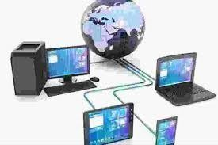

*Table 34: Network Interface Card (NIC)*

* A NIC, also known as a network adapter or LAN adapter, is a hardware component that enables devices to connect to a network. It provides the physical interface between a device (such as a computer or server) and the network medium (such as Ethernet cables or wireless signals).

##### + Switch:

* A switch is a network device that connects multiple devices within a local area network (LAN). It operates at the data link layer (layer 2) of the OSI model and forwards data packets to the appropriate destination based on MAC addresses.

##### + Hub:

* A hub is a basic network device that connects multiple devices within a LAN. It operates at the physical layer (layer 1) of the OSI model and simply broadcasts data to all connected devices, which can result in network congestion and reduced performance.

##### + Router:

* A router is a network device that forwards data packets between computer networks. It operates at the network layer (layer 3) of the OSI model and determines the best path for data transmission based on routing tables and network protocols.

##### + Gateway:

* A gateway is a network device that enables communication between networks with different protocols or architectures. It acts as an intermediary, translating data between incompatible networks to facilitate communication.

##### Access Point (AP):

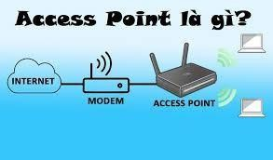

*Table 35: Access Point (AP)*

* + - * + An access point is a device that enables wireless devices to connect to a wired network. It serves as the central connection point for wireless clients, providing access to the network infrastructure.

##### + Modem:

* + - * + A modem is a device that modulates and demodulates digital data to enable communication over analog transmission mediums, such as telephone lines or cable systems. It converts digital signals from computers into analog signals for transmission and vice versa.

##### + Firewall:

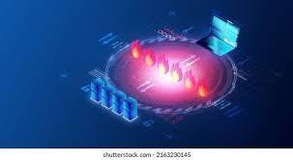

*Table 36: Firewall*

* + - * + A firewall is a network security device that monitors and controls incoming and outgoing network traffic based on predetermined security rules. It acts as a barrier between a trusted internal network and untrusted external networks, such as the internet.

##### + Load Balancer:



*Table 37: Load Balancer*

* + - * + A load balancer is a network device that distributes incoming network traffic across multiple servers or resources to optimize performance, maximize throughput, and ensure high availability of applications or services.

##### + Proxy Server:



*Table 38: Proxy Server*

* + - * + A proxy server is a network device that acts as an intermediary between clients and servers. It intercepts client requests and forwards them to the appropriate server, caching frequently accessed content to improve performance and providing additional security features such as content filtering and anonymity.

1. **Sever :**
   1. **What is a Server:**

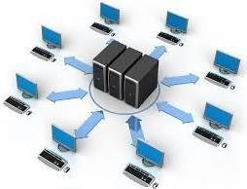

*Table 39: 2.1What is a Server*

- A server is a computer or software system that provides services, resources, or functionality to other computers, devices, or users within a network. Servers are designed to fulfill specific roles and responsibilities within a networked environment, such as hosting websites, storing and sharing files, managing network resources, providing email services, running applications, and more.

Here are some key aspects of servers:

+ **Providing services and resources**: Servers can provide services such as data storage (file server), website serving (web server), email (mail server), printing (print server), database server, file sharing server, and many other services based on different applications and protocols.

+ **Processing requests from clients:** The server is the place that receives requests from clients on the network and processes them to satisfy those requests. For example, a web server receives a web page request from the user's web browser and sends back the content of that web page.

+ **Data storage and management:** Servers are often used to store and manage files and data of an organization or business. They can be configured with RAID (Redundant Array of Independent Disks) systems to protect data and ensure high availability.

+ **Security and access control:** Servers often have security mechanisms to protect data and prevent unauthorized access. Email servers, for example, need to authenticate users before sending or receiving messages.

**+ 24/7 operation:** Servers are usually set up to operate continuously, 24 hours a day, 7 days a week to ensure availability for user requests anytime, anywhere.

### 3.3 Types of servers (Web Sever, File Sever, Database Sever, Email Sever, DNS Sever, …)

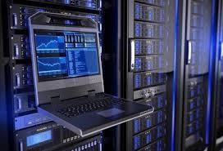

*Table 40: Types of servers*

##### - Certainly! Here are some common types of servers along with brief descriptions of each:

**+ Web Server:**

* A web server is a server that hosts websites and web applications accessible over the internet or intranet. It serves web content in response to client requests made through web browsers. Common web server software includes Apache HTTP Server, Nginx, Microsoft Internet Information Services (IIS), and LiteSpeed.

##### + File Server:

A file server is a server that stores and shares files and documents across a network. It provides centralized storage and access control for users to store, retrieve, and manage files. File servers often support protocols such as Server

Message Block(SMB)/Common Internet File System (CIFS), Network File System (NFS), and FTP (File Transfer Protocol).

##### + Database Server:

* A database server is a server that hosts databases and manages data storage, retrieval, and manipulation. It stores structured data in tables and provides access to databases through database management systems (DBMS) such as MySQL, PostgreSQL, Microsoft SQL Server, Oracle Database, and MongoDB.

##### + Email Server:

* An email server, also known as a mail server, is a server that manages email communication and messaging services for users. It sends, receives, and stores email messages, manages user mailboxes, and handles email routing and delivery. Popular email server software includes Microsoft Exchange Server, Postfix, Sendmail, and Exim.

##### + DNS Server:

* A DNS (Domain Name System) server is a server that resolves domain names to IP addresses and vice versa, facilitating communication between devices on the internet or local network. It translates human-readable domain names (e.g., [www.example.com)](http://www.example.com/) into numeric IP addresses (e.g., 192.0.2.1) used by computers to identify each other. Common DNS server software includes BIND (Berkeley Internet Name Domain), Microsoft DNS Server, and Unbound.

##### + Proxy Server:

* A proxy server is a server that acts as an intermediary between clients and servers. It intercepts client requests and forwards them to the appropriate server, caching frequently accessed content to improve performance and providing additional security features such as content filtering and anonymity. Examples of proxy server software include Squid, Nginx, Apache Traffic Server, and Microsoft Forefront Threat Management Gateway (TMG).

##### + Application Server:

* An application server is a server that runs and manages software applications

and services for client devices. It provides an execution environment and runtime environment for applications, allowing them to handle business logic, data processing, and user interactions. Application servers often support programming languages and frameworks such as Java EE (Enterprise Edition), Microsoft .NET, Node.js, and Ruby on Rails.

##### + Print Server:

* A print server is a server that controls printing resources and manages print jobs from client devices. It receives print requests from clients, spools print jobs, and forwards them to printers or multifunction devices for output. Print servers facilitate centralized printer management and administration in networked environments.

## Discuss the relationship of workstation hardware with networking software.

### The inter-dependence of workstation hardware with relevant networking software..

* The interdependence of workstation hardware with relevant networking software is essential for ensuring smooth and efficient communication and functionality within a networked environment. Here's how workstation hardware and networking software interact and depend on each other:
* The relationship between a workstation's hardware and software is necessary and closely interacts to ensure the computer operates properly and meets the needs of the user and the network. Both of these parts are core elements in the design and management of modern computer systems.

### Network Interface Card (NIC) and Drivers:

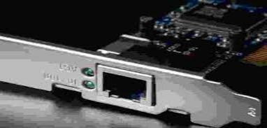

*Table 41: Network Interface Card (NIC) and Drivers*

* Workstation hardware includes network interface cards (NICs) responsible for connecting the workstation to the network. NICs require compatible drivers, which are software components that enable the operating system to communicate with and control the NIC. Without proper drivers, the NIC cannot function correctly, impacting the workstation's ability to connect to the network.

### Operating System Networking Stack:

*Table 42: Operating System Networking Stack*

Workstation operating systems contain networking stacks, which are software components responsible for managing network communication. The networking stack includes protocols, drivers, and utilities for tasks such as packet

processing, address resolution, and network configuration. The efficiency and compatibility of networking software depend on the workstation's hardware capabilities and drivers.

### Network Protocols and Services:

* Networking software on workstations relies on network protocols and services to facilitate communication with other devices on the network. Protocols such as TCP/IP, UDP, DHCP, DNS, and HTTP govern how data is transmitted, received, and processed across the network. Workstation hardware must support these protocols, and the networking software must be compatible with the protocols used in the network environment.

### Firewall and Security Software:

* Workstations often run firewall and security software to protect against unauthorized access and malicious threats. These security solutions depend on the underlying hardware's processing power and capabilities to perform tasks such as packet inspection, intrusion detection, and encryption. Effective security software requires hardware resources such as CPU, memory, and network throughput to function optimally.

### Virtualization and Network Virtualization:

Workstations may utilize virtualization software to run multiple virtual machines (VMs) concurrently on the same hardware. Network virtualization technologies, such as virtual switches and network overlays, depend on the underlying workstation hardware to provide network connectivity and resources to VMs. Compatibility between virtualization software and workstation hardware is crucial for efficient network virtualization.

### Performance and Scalability:

* The performance and scalability of networking software depend on the workstation's hardware specifications, including CPU, memory, storage, and

network interfaces. Workstations with higher processing power, memory capacity, and network bandwidth can handle more intensive networking tasks and support larger numbers of network connections and services.

### Workstation hardware (CPU, GPU, Memory: Ram, Rom, Motherboard, Storage Drives, input device, output device, …)

##### CPU (Central Processing Unit):



*Table 43: CPU*

+ The CPU, often referred to as the processor, is the primary component responsible for executing instructions and performing calculations in a computer. It interprets and executes program instructions, manages data processing tasks, and coordinates communication between other hardware components.

##### GPU (Graphics Processing Unit):

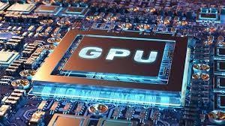

*Table 44: GPU*

+ The GPU, or graphics card, is a specialized processor designed to handle graphics- related tasks such as rendering 2D and 3D images, processing visual effects, and accelerating video playback. It offloads graphics processing from the CPU, improving performance in graphics-intensive applications such as gaming, design, and multimedia editing.

##### - Memory (RAM - Random Access Memory):

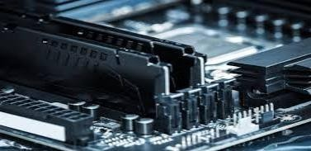

*Table 45: Memory*

+ RAM is a type of volatile memory used by the CPU to temporarily store data and program instructions that are actively being used or processed. It provides fast access to data for the CPU, enabling efficient multitasking, application

performance, and responsiveness. RAM is cleared when the computer is powered off.

##### Storage Drives (HDD, SSD, NVMe):

+ Storage drives are used to store and retrieve data, programs, and operating system files on a computer. Common types of storage drives include:

* **HDD (Hard Disk Drive)**: Uses rotating magnetic platters to store data and is known for its relatively large capacity and affordable cost.

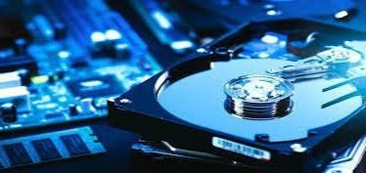

*Table 46: HDD*

* **SSD (Solid State Drive)**: Uses flash memory chips to store data and offers faster read and write speeds, lower power consumption, and improved durability compared to HDDs.

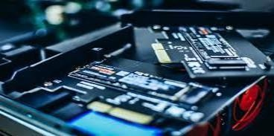

*Table 47: SSD*

* **NVMe (Non-Volatile Memory Express)**: An interface protocol designed for

SSDs to take advantage of high-speed PCIe connections, offering even faster data transfer speeds than traditional SATA-based SSDs.



*Table 48: NVMe*

##### + Motherboard:

* The motherboard is the main circuit board in a computer that houses and connects various hardware components, including the CPU, memory, storage drives, expansion cards, and peripherals. It provides the electrical and mechanical connections needed for communication between components and serves as the foundation for the computer's architecture.

##### + Input Devices:

* Input devices allow users to interact with the computer by providing input data or commands. Common input devices include:
* **Keyboard**: Used for typing text, entering commands, and navigating the user interface.
* **Mouse**: Used for pointing, clicking, and selecting items on the screen.
* **Touchpad**: A built-in pointing device found on laptops and some desktop keyboards, used for cursor control and gestures.
* **Touchscreen**: A display that can detect and respond to touch input, allowing direct interaction with on-screen elements without the need for a separate pointing device.

##### + Output Devices:

* Output devices display or present information generated by the computer to the user. Common output devices include:
* **Monitor**: Displays visual output such as text, images, and video on a screen.
* **Printer**: Produces hard copies of documents, images, and other content.
* **Speakers**: Outputs audio and sound effects generated by the computer's audio hardware.
* **Headphones**: Output audio for private listening and communication.

##### + ROM (Read-Only Memory):

* ROM is a type of non-volatile memory used to store firmware or system software that is permanently programmed during manufacturing. It contains essential instructions for booting the computer and initializing hardware components but cannot be modified or overwritten during normal operation.

## Networking software (define, function, components, types, …)



*Table 49: Networking software*

* Networking software refers to the collection of programs, protocols, and utilities that enable communication and data exchange between devices within a computer network. It plays a crucial role in facilitating network connectivity, managing network resources, and ensuring efficient data transmission. Here's an overview of networking software:

##### + Definition:

* Networking software encompasses a wide range of applications and protocols designed to facilitate communication, resource sharing, and collaboration between devices within a networked environment. It includes both operating system components and standalone applications that provide networking functionality.

##### + Functions:

Networking software performs various functions to enable communication and data exchange within a network, including:

* **Network Configuration**: Configuring network settings such as IP addresses, subnet masks, and DNS servers.
* **Protocol Stacks**: Implementing networking protocols such as TCP/IP, UDP, ICMP, DHCP, DNS, HTTP, and FTP to enable data transmission and communication.
* **Resource Sharing**: Facilitating file sharing, printer sharing, and other resource sharing activities within a network.
* **Network Security**: Implementing security measures such as firewalls, encryption, authentication, and access control to protect network resources and data.
* **Network Monitoring**: Monitoring network traffic, performance, and health to detect issues, troubleshoot problems, and optimize network performance.
* **Remote Administration**: Providing tools and utilities for remotely managing and administering network devices, services, and configurations.

##### + Components:

Networking software consists of various components, including:

* **Network Protocols**: Protocols define the rules and conventions for communication between devices within a network. Examples include TCP/IP, UDP, ICMP, DHCP, DNS, HTTP, FTP, and SNMP.
* **Network Services**: Services are software applications or processes that provide specific functions or capabilities within a network, such as file sharing (SMB/CIFS), printing (LPD), email (SMTP/POP/IMAP), and directory services (LDAP).
* **Network Utilities**: Utilities are tools and programs used for network administration, troubleshooting, and monitoring. Examples include ping, traceroute, ipconfig/ifconfig, netstat, nslookup, and Wireshark.
* **Network Operating Systems (NOS)**: NOSs are specialized operating systems designed to provide networking functionality and services. Examples include Windows Server, Linux/Unix distributions, and network-centric operating systems like Cisco IOS and Juniper Junos.

##### + Types:

Networking software can be categorized into several types based on their functions and capabilities, including:

* **Operating System Networking Stack**: Networking components and protocols integrated into the operating system to provide basic networking functionality.
* **Network Management Software**: Tools and applications for managing and monitoring network devices, services, and performance.
* **Network Security Software**: Software solutions for protecting network resources, data, and communications from unauthorized access, intrusion, and threats.
* **Network Services and Applications**: Applications and services that provide specific functionality within a network, such as web servers, email servers, DNS servers, and file servers.
* **Network Utilities and Tools**: Tools and utilities for network administration, troubleshooting, and diagnostics, such as packet analyzers, network scanners, and configuration management tools.

## Explore a range of server types and justify the selection of a server for a given scenario, regarding cost and performance optimisation.

**-** When selecting a server for a specific scenario, several factors need to be considered, including cost, performance, scalability, reliability, security, and the specific requirements of the workload or application being hosted. Here's an exploration of different server types and considerations for selecting the most suitable server for a given scenario, balancing cost and performance optimization:

### Physical Servers:



*Table 50: Physical Servers*

* **Description:** These are traditional servers that exist as physical hardware in a data center.
* **Cost Consideration:** Initial setup costs can be high due to the need to purchase hardware. However, long-term operating costs may be lower compared to cloud-based solutions.
* **Performance:** Typically offers high performance and low latency, especially for workloads that require dedicated resources.
* **Scalability:** Limited scalability compared to cloud solutions. Scaling requires purchasing additional hardware.
* **Justification:** Physical servers are suitable for workloads with predictable resource needs, long-term stability requirements, or strict compliance/regulatory requirements where data must remain on-premises.

##### Virtual Private Servers (VPS):



*Table 51: Virtual Private Servers (VPS)*

* + **Description:** VPS hosting involves partitioning a physical server into multiple virtual servers.
  + **Cost Consideration:** Generally more affordable than dedicated physical servers. Costs are often based on allocated resources.
  + **Performance:** Performance can vary depending on the underlying physical hardware and the hypervisor's efficiency.
  + **Scalability:** Limited scalability compared to cloud solutions. Upgrading resources may require migrating to a different VPS tier.
  + **Justification:** VPS is suitable for small to medium-sized businesses or applications with moderate resource requirements, offering a balance between performance and cost-effectiveness.

##### Cloud Servers (IaaS):

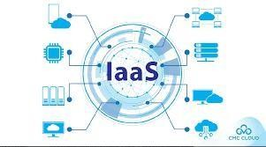

*Table 52: Cloud Servers (IaaS)*

* + **Description:** Cloud servers are virtual servers provided by cloud service providers (e.g., AWS EC2, Azure VMs, Google Compute Engine).
  + **Cost Consideration:** Pay-per-use pricing model allows for cost optimization by scaling resources up or down based on demand. Initial setup costs are usually lower compared to physical servers.
  + **Performance:** Performance can vary depending on the cloud provider, instance type, and selected resources. Some cloud providers offer high- performance computing (HPC) instances for demanding workloads.
  + **Scalability:** Highly scalable, allowing for instant provisioning and scaling of resources based on demand.
  + **Justification:** Cloud servers are suitable for dynamic workloads, applications with unpredictable traffic patterns, or businesses looking to leverage the flexibility and scalability of cloud computing while controlling costs.

##### Containerized Servers (e.g., Docker, Kubernetes):

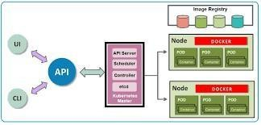

*Table 53: Containerized Servers (e.g., Docker, Kubernetes)*

* + **Description:** Containers provide lightweight, portable, and scalable environments for running applications.
  + **Cost Consideration:** Containers can be more cost-effective compared to traditional virtualization methods as they allow for

better resource utilization and efficient scaling.

* + **Performance:** Containers introduce minimal overhead, providing near-native performance for applications.
  + **Scalability:** Highly scalable, allowing for rapid deployment and scaling of containerized applications.
  + **Justification:** Containerized servers are suitable for microservices architectures, modern application development practices (e.g., DevOps), and environments where rapid deployment, scalability, and resource efficiency are essential.

##### Serverless Computing (e.g., AWS Lambda, Azure Functions):



*Table 54: Serverless Computing (e.g., AWS Lambda, Azure Functions)*

* + **Description:** Serverless computing abstracts server management, allowing developers to focus on writing code without worrying about server provisioning or management.
  + **Cost Consideration:** Costs are based on actual usage (e.g., number of executions, compute time), making serverless computing highly cost- effective for applications with unpredictable workloads or sporadic usage patterns.
  + **Performance:** Offers low latency and high scalability, with cloud providers managing underlying infrastructure to ensure optimal performance.
  + **Scalability:** Automatically scales resources based on demand,

allowing for seamless handling of fluctuating workloads.

* + **Justification:** Serverless computing is suitable for event-driven applications, batch processing, or scenarios where cost optimization, scalability, and rapid development are top priorities.



*Table 54: Serverless Computing (e.g., AWS Lambda, Azure Functions)*

* + **Description:** Serverless computing abstracts server management, allowing developers to focus on writing code without worrying about server provisioning or management.
  + **Cost Consideration:** Costs are based on actual usage (e.g., number of executions, compute time), making serverless computing highly cost- effective for applications with unpredictable workloads or sporadic usage patterns.
  + **Performance:** Offers low latency and high scalability, with cloud providers managing underlying infrastructure to ensure optimal performance.
  + **Scalability:** Automatically scales resources based on demand, allowing for seamless handling of fluctuating workloads.
  + **Justification:** Serverless computing is suitable for event-driven applications, batch processing, or scenarios where cost optimization, scalability, and rapid development are top priorities.

## Evaluate the topology and protocol suite selected for a given scenario and how it demonstrates the efficient utilisation of a networking system.

##### - Scenario:



*Table 55: Scenario*

+ A medium-sized business with multiple departments spread across different floors of a building needs to establish a robust and efficient networking system to support its operations. The business requires reliable connectivity, seamless communication between departments, efficient resource sharing, and secure access to centralized services.

### Topology:

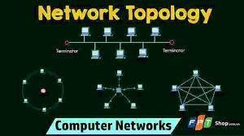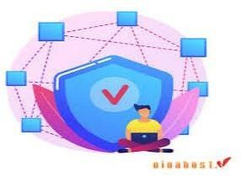

*Table 56: Topology*

+ For this scenario, a hierarchical or tree topology would be suitable:

* + **Core Layer**: This layer connects all the distribution switches and provides high-speed connectivity to the backbone network and centralized services.
  + **Distribution Layer**: Distribution switches connect the core layer to the access layer switches on each floor. They manage traffic distribution and implement policies for access control and quality of service (QoS).
  + **Access Layer**: Access switches are deployed on each floor to connect end-user devices (computers, printers, phones) to the network. They provide connectivity to the distribution layer and manage local traffic.

### Protocol Suite:

*Table 57: Protocol Suite*

+ The selected protocol suite should support the requirements of the scenario, including reliability, scalability, security, and efficient resource utilization. A common choice for modern networking systems is the TCP/IP protocol suite:

* + **Transmission Control Protocol (TCP) / Internet Protocol (IP**): TCP/IP provides reliable and connection-oriented communication between devices across the network. IP handles routing and addressing, while TCP ensures data

integrity and flow control.

* + **Ethernet**: Ethernet is used for local area network (LAN) connectivity, providing a standard for data link layer communication. It supports high- speed, reliable communication between devices within the same network segment.
  + **Spanning Tree Protocol (STP)**: STP prevents loops in redundant network topologies by disabling redundant paths. It ensures network stability and efficient utilization of network resources by maintaining a loop-free topology.
  + **Virtual LANs (VLANs)**: VLANs are used to segment the network into logical broadcast domains, improving network performance and security. They enable efficient resource utilization by grouping devices based on department or function.
  + **Quality of Service (QoS) Protocols**: QoS protocols such as Differentiated Services (DiffServ) or Integrated Services (IntServ) can be implemented to prioritize traffic based on specific requirements, ensuring optimal performance for critical applications.

1. Efficient Utilization of Networking System:

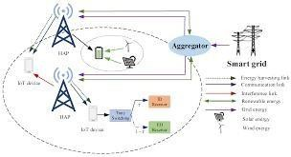

Table 58: Efficient Utilization of Networking System

**+ Scalability**: The hierarchical topology allows for easy scalability as the business grows. New departments or floors can be seamlessly added to the network without disrupting existing operations.

**+ Resource Optimization**: By segmenting the network into VLANs and implementing QoS policies, resources can be efficiently utilized to prioritize critical traffic, optimize bandwidth usage, and improve overall network performance.

**+ Redundancy and Reliability**: Redundant links and devices at each layer of the hierarchy ensure high availability and reliability. Protocols like STP prevent network loops and ensure stable operation.

**+ Centralized Management**: The core layer facilitates centralized management of network resources and services, simplifying administration and troubleshooting tasks.

**+ Security**: VLAN segmentation enhances network security by isolating sensitive data or devices from unauthorized access. Additionally, protocols like IPsec can be implemented to secure data transmission over the network.

#### B. conclusion :

An Assignment paper for the Networking subject has many issues that need to be resolved, such as content, images, and presentation arguments. To complete an Assignment lesson in the Networking subject, it takes a lot of time and dedication to complete the lesson and achieve the best results in the subject. Networking is one of the subjects that requires a lot of concentration because it is not an easy subject to study. Understanding it will help you know that there are many types of networks in the world and around us.

#### C. References :

Cambridge Dictionary (2024). commuter. [online] @CambridgeWords. Available at: https://dictionary.cambridge.org/vi/dictionary/english/commuter [Accessed 27 Jun. 2024].

Cambridge Dictionary (2024). commuter. [online] @CambridgeWords. Available at: https://dictionary.cambridge.org/vi/dictionary/english/commuter [Accessed 27 Jun. 2024].

Cambridge Dictionary (2024). topology. [online] @CambridgeWords. Available at:

https://dictionary.cambridge.org/vi/dictionary/english/topology [Accessed 27 Jun. 2024].

Anon, (2024). [2024] Mô hình OSI là gì? | Vai trò & Chức năng của 7 tầng OSI. [online] Available at: https://vinahost.vn/mo-hinh-osi-la-gi/ [Accessed 27 Jun. 2024].

# Introduce

This report aims to provide a comprehensive overview of networking principles, protocols, and devices in the context of a networking project for a local educational institute. The project involves connecting 200 students, 15 teachers, 12 administrative staff, and 5 higher management personnel across a three-story building. The report will delve into the benefits and constraints of various network types and standards, the impact of network topology, speed, and bandwidth, and the effectiveness of different networking systems. Furthermore, it will explore the functioning of networking devices, server types, and software, as well as the relationship between workstation hardware and networking software. The report will also analyze server options, considering cost and performance optimization, and propose a suitable topology protocol for efficient network utilization.

+) Design an effective networking system:

* 1. Prepare a written step-by-step plan of how I will design my Local Area Network including a blueprint of my LAN.
  2. Explain device selection for network design.
  3. Plan a test to evaluate this design for bandwidth requirements and cost constraints according to user specifications.
  4. Explain the security and service quality requirements necessary for accessory selection.
  5. Propose a maintenance schedule to support the networked system.

+) Perform testing and diagnosis of networked systems:

1. Deploy the networked system based on the prepared design.
2. Conduct verification by e.g. Ping, extended ping, traceroute, telnet, SSH, etc.
3. Record test results and analyze them against expected results.
4. Investigate what functions will enable the system to support device growth and the addition of communications devices.
5. Discuss the importance of the upgrade and the security requirements of my proposal.

# Body

### P5 Design a networked system to meet a given specification

1. **Provide a logical/physical design of the networked system with clear explanation and addressing table.**

##### Explain the difference between logical and physical de.

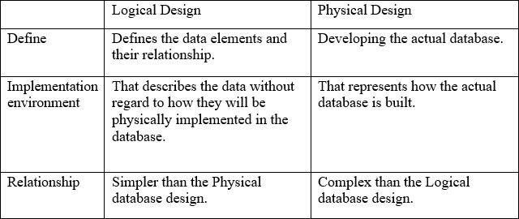

**- Conclude:**

+ To deploy a network, we need to have a logical network design, based on which to deploy an effective physical network design. And the physical network design is the actual network devices that will be installed.

##### Discuss and explain the USER Requirement for the design

* + - **Customer request:**

**+ People :** 100 students, 10 teachers, 8 marketing and administration staff, 4 higher managers including the head of academics and the programmer manager, 2 computer network administrators.

**+ Resources:** 40 student lab computers, 30 staff computers, 3 printers.

**+ Building:** 3 floors, all computers and printers are on the ground floor apart from the IT labs – one lab located on the first floor and another located on the second floor.

##### - Explain customer requirement:

+ **Ground Floor:** 35 computers (including 15 teachers, 9 SEO, 5 Header, 3 Server Rooms, 3 IT) and 3 printers.

+ **First Floor:** 25 student computers lab 1

+ **Second Floor:** 25 student computers lab 2

* **System requirement:**

**+ Connectivity:**

* + All computers (student labs, staff labs) and printers need network connectivity.
  + IT labs on the 1st and 2nd floors require strong, high-speed connectivity**.**

##### + Network Infrastructure:

* + **Switches:** Sufficient number of switches to support the total number of devices.
  + **Routers:** To manage storage between floors and provide internet access.
  + **Access Points:** For wireless connectivity, especially in common areas and possibly in labs.
  + **Cables:** Sufficient cables to connect all devices to the infrastructure network.

##### + IP Addresses:

* + An appropriate IP addressing scheme to efficiently manage the network and ensure each device has a unique IP address.

##### + Security:

* + Implement network security measures such as Firewalls, VLANs, and secure access protocols.
  + Ensure data sensor protection, especially for administrative and staff computers.

##### + Quality of Service (QoS):

* + Ensure that critical applications (such as educational software and administrative tools) have sufficient bandwidth and are prioritized over non-critical volumes.
  + Scalability: The network design should allow for easy expansion to accommodate future growth, given constraints such as adding more devices or upgrading infrastructure.

##### + Maintenance and Support:

* + Plan for regular maintenance and updates.
  + Provide technical support to quickly resolve network issues.

##### + Documentation and Training:

* + Comprehensive documentation of network design, configuration, and policies.
  + Training for network administrators to effectively manage and troubleshoot the network.

### P6 Design a maintenance schedule to support the networked system

##### Logical design of the network based on user requirements:

* + - **Build an IP address table for each device.**

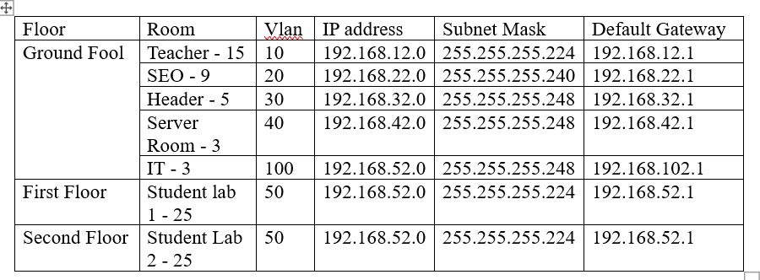

* + - **Analyze the sub interface division:**

+ **Teachers:** 15

* + - * **VLAN 10:** IP 192.168.12.0/27 (30 usable IPs)
      * **Default gateway:** 192.168.12.1
      * **Usage:** Suitable for 15 teachers with room for future devices.

+ **SEO:** 9

* + - * **VLAN 20:** IP 192.168.22.0/28 (14 usable IPs)
      * **Default gateway:** 192.168.22.1
      * **Usage:** Suitable for 9 SEO staff and additional devices.

+ **Header:** 5

* + - * **VLAN 30:** IP 192.168.32.0/29 (6 usable IPs)
      * **Default gateway:** 192.168.32.1
      * **Usage:** Suitable for 5 header staff with one spare IP.

+ **Server Room:** 3

* + - * **VLAN 40:** IP 192.168.42.0/29 (6 usable IPs)
      * **Default Gateway:** 192.168.42.1
      * **Usage:** Suitable for 3 servers, room for expansion.

+ **IT:** 3

* + - * **VLAN 100:** IP 192.168.102.0/29 (6 usable IPs)
      * **Default Gateway:** 192.168.102.1
      * **Usage:** Suitable for 3 IT staff, allowing for future growth.

**+ Student Lab 1:** 25 (Floor 1)

* + - * **VLAN 50:** IP 192.168.52.0/27 (30 usable IPs)
      * **Default Gateway:** 192.168.52.1
      * **Usage:** Suitable for 25 student lab computers, with backup IPs.

**+ Student Lab 2:** 25 (Floor 2)

* + - * **VLAN 50 (Shared):** IP 192.168.52.0/27 (30 usable IPs)
      * **Default Gateway:** 192.168.52.1
      * **Usage:** Same as Student Lab 1, suitable for 25 computers.

**- Provide logical design of the network (cisco paket tracer)**

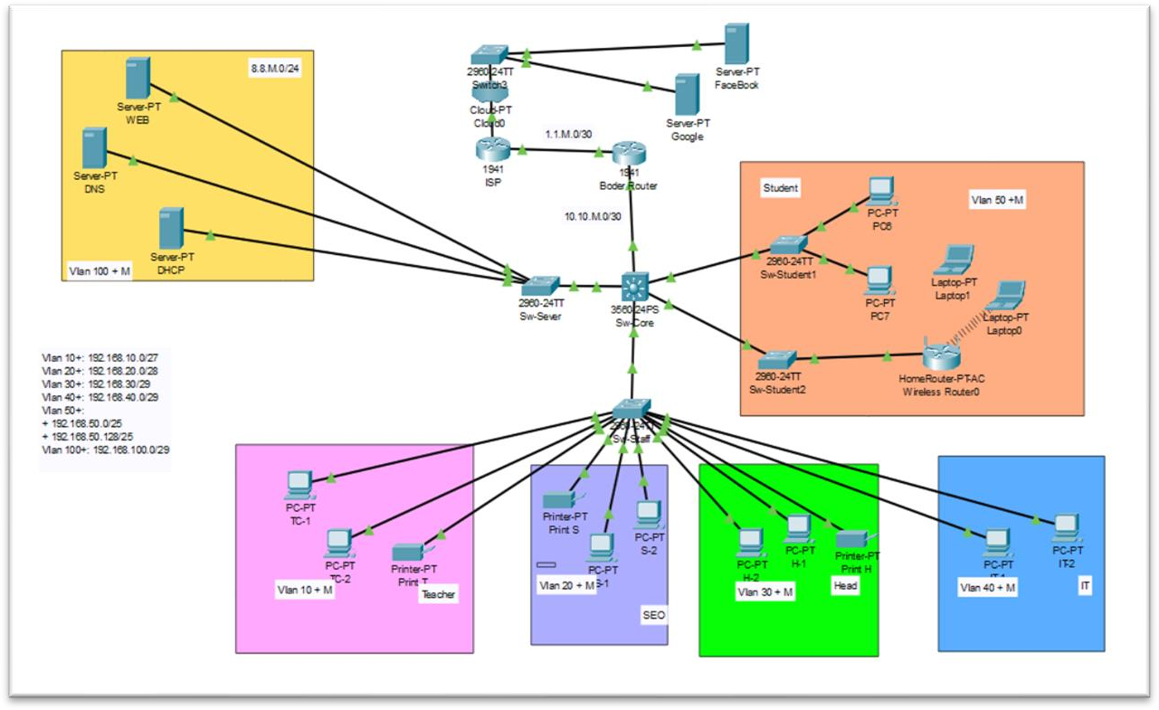

- **VLAN:**

+ **VLAN 10**: Students

+ **VLAN 20:** Teachers

+ **VLAN 30:** Admin Staff

+ **VLAN 40:** Management

+ **VLAN 50:** Network Admins

* **Core Devices:**

+ **Access Switches:** Cisco 2960

* **Security:**

+ **Firewall:** Cisco ASA 5500

* **IP Ranges:**

+ **VLAN 10:** 192.168.12.0

+ **VLAN 20:** 192.168.22.0

+ **VLAN 30:** 192.168.32.0

+ **VLAN 40:** 192.168.42.0

+ **VLAN 50:** 192.168.52.0

##### Physical design of the network based on user requirements. (Use draw.io)

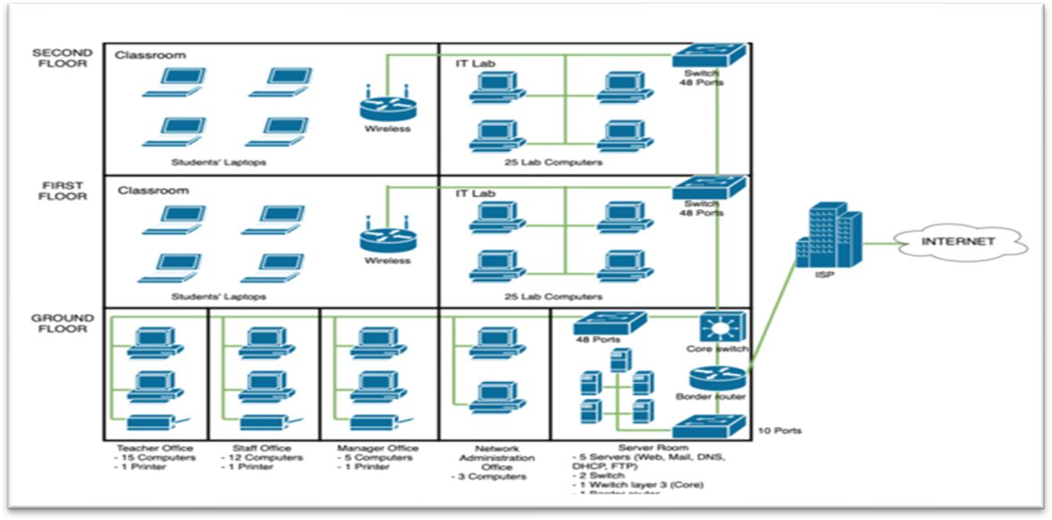

* + - **Analyze physical design:**
      * The physical network design is spread across three floors of a building. The network utilizes a hierarchical star topology, with a core switch (Cisco 9300) located in the server room on the

ground floor, which connects to access switches (Cisco 2960) on each floor. The access switches provide connectivity to end devices such as computers and printers.

**+ Ground Floor:** The core switch connects to several staff computers and printers, ensuring robust network connectivity. Additionally, servers (Dell PowerEdge R740) are located on this floor, providing centralized services like DHCP, DNS, and file sharing. Redundant links and an Uninterruptible Power Supply (UPS) are in place to maintain network reliability.

+ **First Floor**: An access switch connects to the IT Lab 1, providing network access to student computers. Wireless access points (Cisco Aironet 3800) are also deployed to ensure comprehensive Wi-Fi coverage.

+ **Second Floor:** Another access switch serves IT Lab 2, connecting to additional student computers. Like the first floor, this floor also benefits from wireless access points for seamless wireless connectivity.

### Design a maintenance schedule to support the networked system.

##### Network maintenance definition.

* + - **Network maintenance:** is the ongoing process of managing, monitoring, and servicing a network to ensure its optimal performance, reliability, and security. It includes tasks such as monitoring network performance, troubleshooting issues, applying updates and patches, managing security, and performing regular backups to keep the network running smoothly and securely.

##### Task for maintenance plan:

* + - Help with a maintenance plan, I'll need more specific details about the task at hand. Could you please provide more context or specify the area you're focusing on? For example:
      * Is it for machinery, software, infrastructure, or another area?
      * What are the key components or systems involved?
      * What is the goal or outcome you’re aiming to achieve with the maintenance plan?

- The more information you provide, the better I can assist you in creating a detailed and effective plan.

* 1. **Maintenance schedule (week, month, quarter, year, …)**

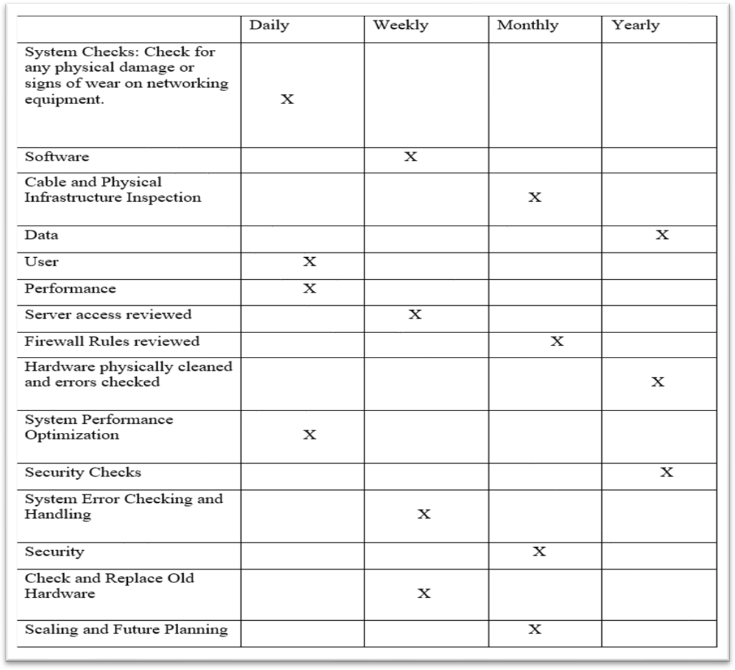

### Implement a networked system based on a prepared design.

##### Set up VTP for the device.

Switch Core

vtp domain btec.vn vtp mode server

vtp password btec123

**- Show :** do show vtp status

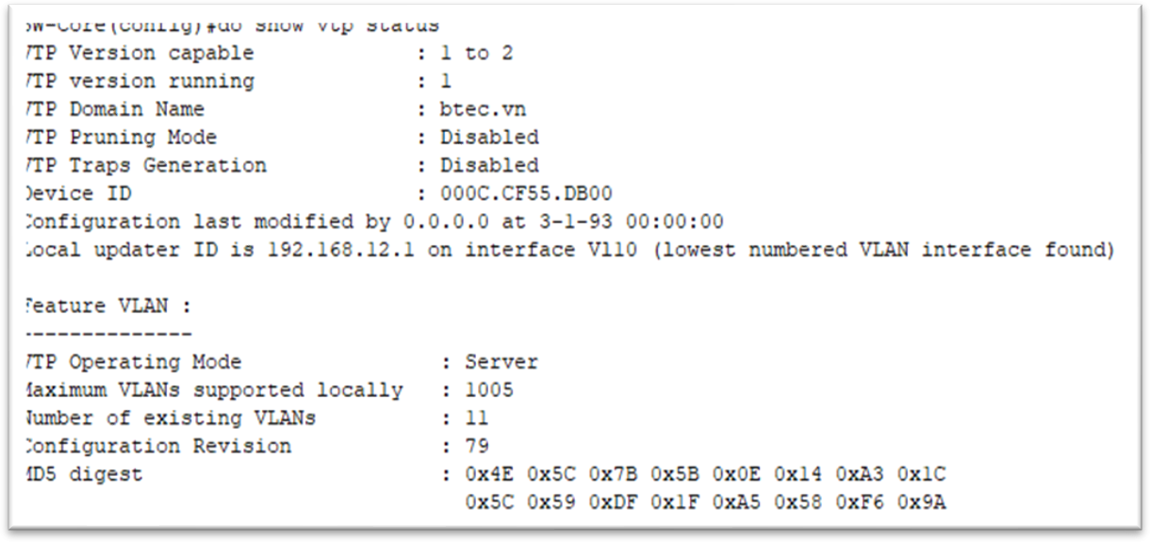

**Switch Service, Switch STD1, SW Student 2, Switch Staff**

vtp mode client vtp domain btec.vn

vtp password btec123

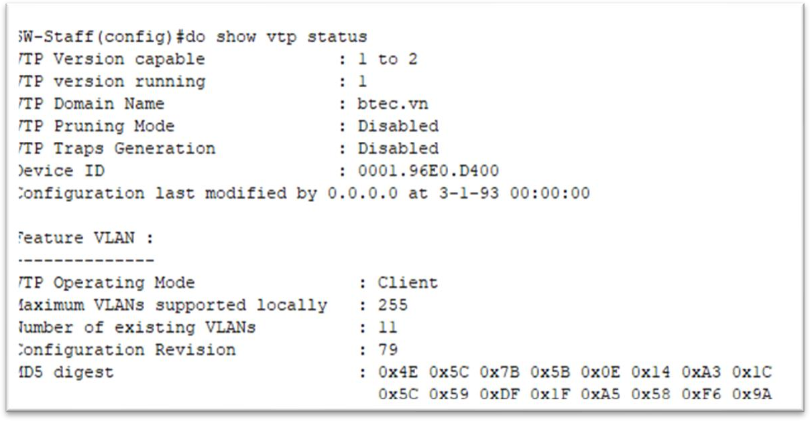

##### Set up vlan networks for devices Gate

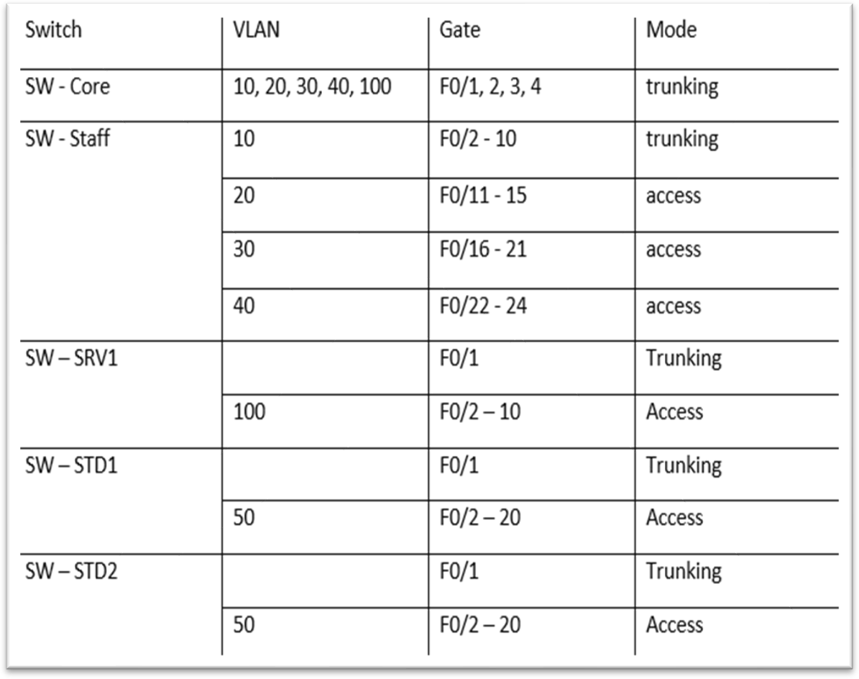

* + - **Declare vlan on Server mode switch and install trunking:**

**+ SW Core:**

vlan 10 teacher name vlan 20

SEO name vlan 30

Name of Head of Department

vlan 40 name it vlan 50

student's name vlan 100

server name

interface range f0/1-4 sw trunk enc dot1q sw mode trunk

**+ Switch Server:** int range f0/2-4 sw mode acc

sw acc vlan 100

**+ Switch STD1, STD2:**

int range f0/2-10 sw mode acc

sw acc vlan 50

**+ Switch Staff:** sw mode acc sw acc vlan 10

int range f0/11-15 sw mode acc

sw acc vlan 20

int range f0/16-21

sw mode acc sw acc vlan 30

int range f0/22-24 sw mode acc

sw acc vlan 40

**+ Check: Do show vlan bri:**

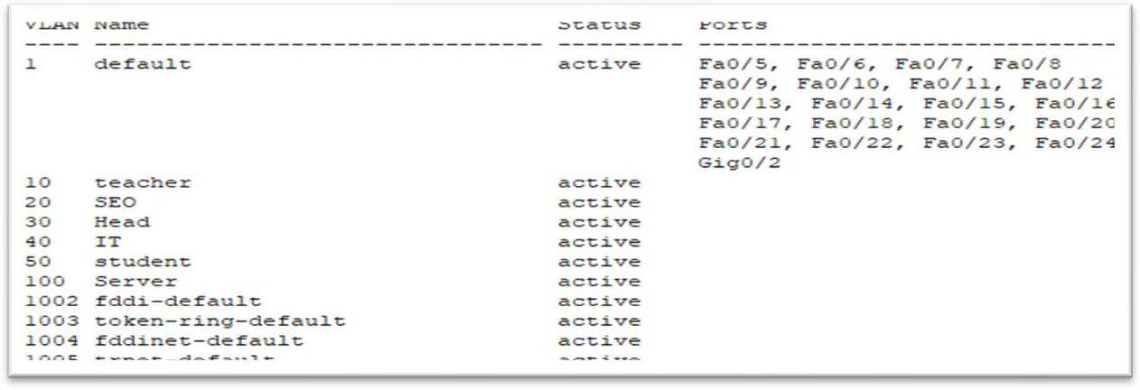

**+ Check : do show int trunk:**

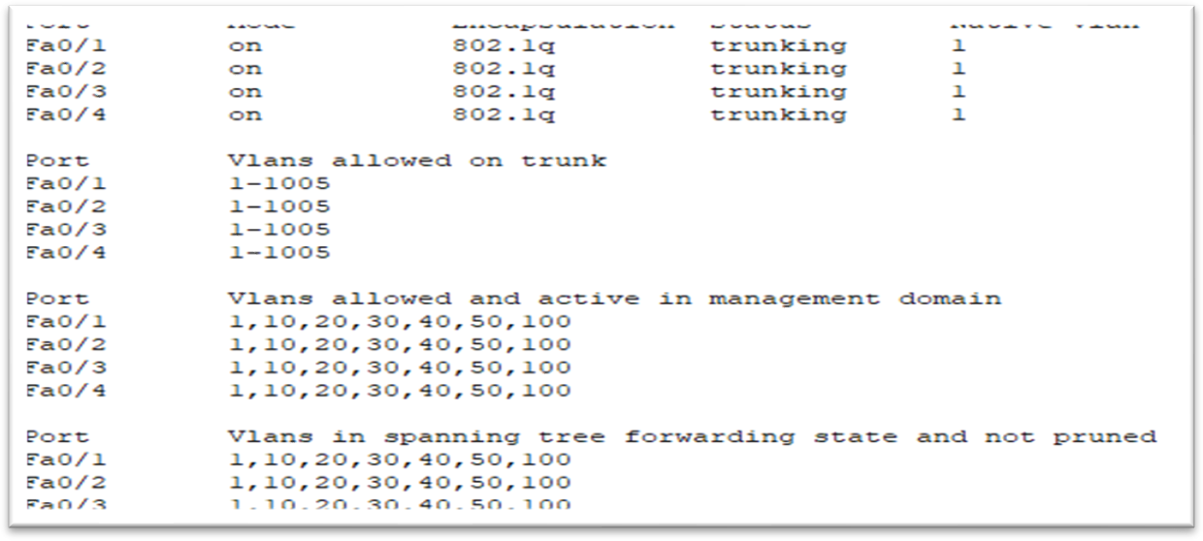

**1. Set up DHCP relay agent and default gateway**

**- Install relay-agent on SW-Core:**

int vlan 10

ip helper-address 192.168.102.2 (dia chi DHCP) int vlan 20

ip helper-address 192.168.102.2

int vlan 30

ip helper-address 192.168.102.2

int vlan 40

ip helper-address 192.168.102.2

int vlan 50

ip helper-address 192.168.102.2

**+ do show run ( Sw -Core):**

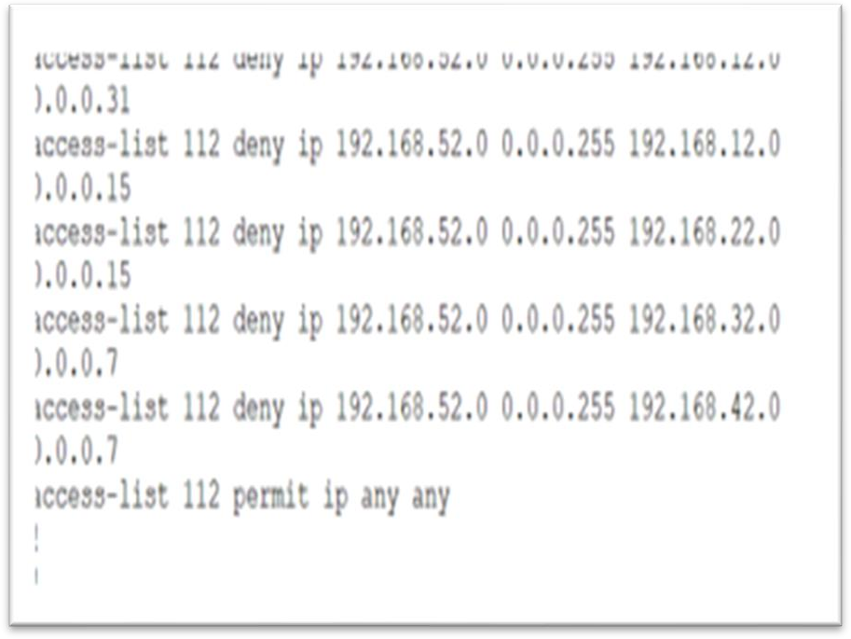

**- Configure routing on sw-core**

int g0/1

no switchport

ip add 10.10.2.1 255.255.255.252

ip route 0.0.0.0 0.0.0.0 10.10.2.2

**+ Do show ip int bri**

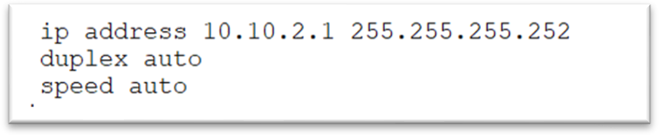

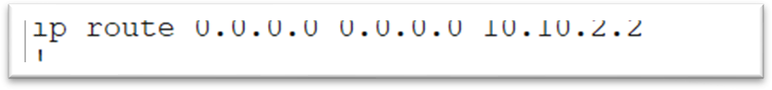

* **Configure routing on R-Boder:**

ip route 192.168.0.0 255.255.0.0 10.10.2.1

ip route 0.0.0.0 0.0.0.0 1.1.2.2

* **Configure routing on ISP:**

ip route 0.0.0.0 0.0.0.0 1.1.0.1

* **Configure NAT on Router-Border:**

int g0/0

ip nat inside int g0/1

ip nat outside

Configure PAT on Router-Border

+Create a list of ip address ranges that need NAT access-list 1 permit 192.168.2.0 0.0.0.31

access-list 1 permit 192.168.2.0 0.0.0.15

access-list 1 permit 192.168.2.0 0.0.0.7

access-list 1 permit 192.168.2.0 0.0.0.7

access-list 1 permit 192.168.2.0 0.0.0.255

access-list 1 permit 192.168.2.0 0.0.0.7

ip nat inside source list 1 int g0/1 overload

**+ do show run NAT:**

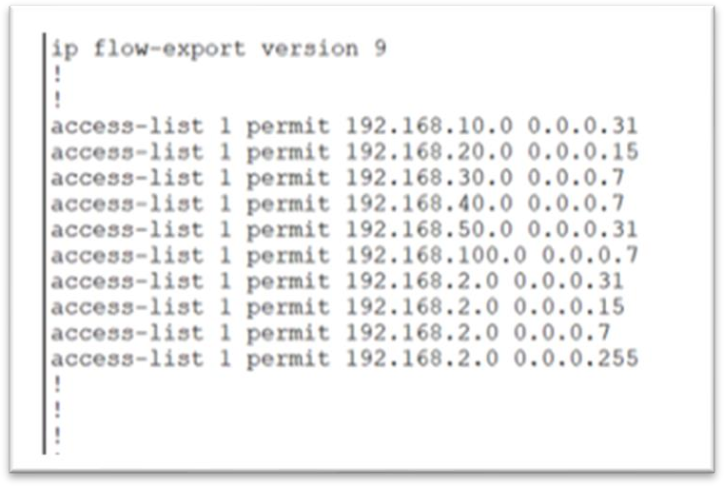

### D2 Critically reflect on the implemented network, including the design and decisions made to enhance the system

1. Evaluation of how the topology
   * **( Star topology ) The system can do it :**
     + **Scalability:** Star topologies are often easy to expand by adding new devices at the center of the network. This facilitates flexible network expansion as needed.
     + **Reliability**: With a star structure, if a device outside the network has a problem, it only affects that device's connection without affecting other devices on the network.
     + **Easy Management**: With each device connected directly to the heart of the network, management and monitoring becomes easier. Any changes or problems that occur can

be quickly detected and resolved.

* + - **Performance:** Star topology can provide high performance for data transmission because there are no interdependent links. This minimizes latency and increases data transfer speeds.

##### - Disadvantages:

* + - **Central failure:** if the hub has a problem, the entire network system will be affected.
    - **Cost:** Star configuration requires power connections and large accessories to connect all devices to the hub. This can increase network operation and maintenance costs.
    - **Complex management:** While central management may be easier, monitoring and managing multiple connections to the hub can also become complex and difficult.
    - **Weaker security:** With all connections centralized at the hub, a security breach or attack on the hub can cause major damage to the entire network.

##### Evaluate the protocols selected

* + **Choosing the protocol also brings some system efficiency as follows:**
    - **DHCP :** A protocol that automatically assigns IP addresses to computers in the system. Not only that, it also helps manage IP addresses to avoid redundant addresses as well as avoid duplication in a network.
    - **VTP :** It helps manage the network better at one root server without having to go to each Switch individually. Helps manage effectively.
    - **DNS :** Resolves IP addresses to domain addresses. Makes it easier to remember instead of remembering the IP address. You don't want numbers always around you in a cyberspace.
    - **NAT** : Hide IP address in the internet environment. Save IP addresses in today's large network environment.
    - **ACL :** Shows the granting of benefits to the network solution. When you want to block a network solution from sending information to another system and vice versa.

##### Some disadvantages:

* + - **DNS :** There are some limitations in terms of speed because it needs to convert domain names to IP addresses.
    - **VTP :** If a device is not configured correctly, it can cause problems such as unstable access or data loss.
    - **NAT :** Complicated and error-prone. Because it is an IP hiding protocol, it may cause some effects on some VPN devices. Not only that, it can also be used by some bad guys to achieve their goals.
    - **ACL :** ACLs can become very complex when many access rules and conditions need to be managed. Incorrect ACL configuration can result in blocking unwanted access or allowing insecure access.

##### Evaluate decisions to improve system efficiency

* + **Some decisions I have made to help with system efficiency:**
    - **Use automated system management:** Easily manage IP Addresses and network solutions in the network system.
    - **Reserve equipment**: promptly respond to special situations.
    - **System maintenance schedule**: Create a maintenance schedule to better manage the system, as well as optimize system performance.
    - **Use 2 connection wires:** Ensure stable bandwidth, no interruption when encountering problems.

##### Unfavorable side:

* + - **Use automated system management:** when management needs to be guaranteed due to a certain complexity.
    - **Use 2 connection wires:** costly to maintain. If STP is not installed, the system will fail.

# Conclution

In conclusion, the successful implementation of a network infrastructure for the educational institute hinges on a thorough understanding of networking fundamentals. By carefully considering factors such as network type, topology, speed, bandwidth, and device selection, Nguyen Networking Limited can design a robust and efficient network solution. The analysis of server options and the proposed topology protocol offer a solid foundation for the project. This report provides a comprehensive framework for the subsequent phases of network design and implementation, ensuring the optimal utilization of network resources to meet the educational institute's specific requirements.

# Reference

* 1. *Explain the difference between physical and logical databases* (no date). [https://www.tutorialspoint.com/explain-the-difference-between-physical-and-](https://www.tutorialspoint.com/explain-the-difference-between-physical-and-logical-databases)

[logical-databases](https://www.tutorialspoint.com/explain-the-difference-between-physical-and-logical-databases).

* 1. Worldwide Services (2023) *What is network maintenance?*

[https://worldwideservices.net/network-](https://worldwideservices.net/network-maintenance-guide-upkeep/)

[maintenance-guide-upkeep/](https://worldwideservices.net/network-maintenance-guide-upkeep/).

* 1. Trout, J. (2015) *Maintenance Planning and Scheduling: An Overview*. [https://www.reliableplant.com/Read/30261/maintenance-](https://www.reliableplant.com/Read/30261/maintenance-planning-scheduling)

[planning-scheduling](https://www.reliableplant.com/Read/30261/maintenance-planning-scheduling).